Synthetic Biology - STEM

Professional Development Workshops

2019 BioBuilder 3-Day Professional Development Workshops will be held at:

- Oxbridge Academy, West Palm Beach, Florida: June 11 - 13

- University of North Carolina, Chapel Hill, North Carolina: July 10 - 12

- University of California, San Diego, California: August 5 - 7

- BioBuilder Learning Lab, Cambridge, Massachusetts: August 6 - 8

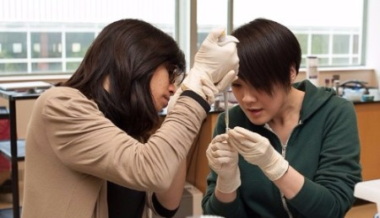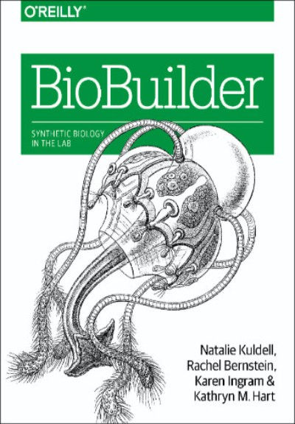
BioBuilder is bringing tomorrow’s science into today’s classrooms, reconnecting teachers and students with the joy of learning.
Our three-day workshops prepare educators to bring biological engineering and synthetic biology into their classrooms and laboratories, using real-world engineering challenges to teach life sciences.

BioBuilder is a one-of-a-kind curriculum in the field of synthetic biology. Synthetic biology is an emerging field that applies engineering and mathematical principles to the development of novel biological systems.

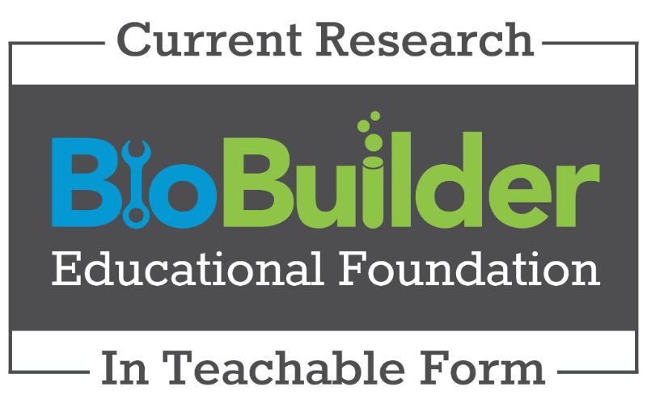

BioBuilder converts cutting-edge science and engineering into teachable modules, fostering an engaged community and increased understanding of these fields. Our curriculum has grown out of a partnership between researchers at MIT and secondary school teachers around the country. BioBuilder connects academia, industry partners and students, creating lasting partnerships critical to solving the STEM challenges of tomorrow.

The workshops will include:
- Lectures that connect the science, technology, engineering, and math aspects of these fields.
- Labs and classroom activities taught from the online www.biobuilder.org resource and the BioBuilder textbook published by O’Reilly.
- Discussion with members of university research communities.
- Activities that address human practice questions such as the safety, security, economics and wisdom of engineering novel biological systems.
- Activities that address the nuts and bolts of running a BioBuilderClub or iGEM team.
- Attendees receive a copy of the BioBuilder textbook, all workshop classroom materials in ready to use formats, lunch each day, and a certificate of completion.
Who should apply?
High school Biology and STEM teachers, college-level instructors, Science Club leaders, and anyone looking for ways to bring cutting-edge content to students with a variety of interests from math to biology to electronics, are all encouraged to attend!

How to apply?
Registration and additional information online.

Tuition is $400 ($450 for CA) when registered by April 1st; $500 ($550 for CA) after April 1st. Scholarships are available.

Questions: please email Carla, Director of Operations: carla@biobuilder.org

The BioBuilder Educational Foundation is a 501(c)3 organization. Donations are tax-deductible and all proceeds go directly to funding the foundation’s programs and materials.

