Aaron M.’s instructions:

To grow up the yeast, I put a healthy 10 ul loop of orange yeast in 150ml of 10% DME (dry malt extract... my substitute for for YPD) in an Erlenmeyer on a stir plate for 48-72 hours. Then I put the flask in the fridge to cold crash. I decant the liquid off the top and add 500ml more fresh 10% DME and return it to the stir plate. After 2-3 days, there should be enough yeast to bake bread. Again, I recommend putting the flask in the fridge to have the yeast flocculated followed by the decanting off the media. If you don't decant off the liquid, the bread basically smells like growth media. The decanting is less of an issue if you use DME than if you use YPD. I've made the bread with YPD and if you decant all the liquid, it comes out OK. To me the DME smells a bit better and I always have it on hand at home. I used the liquid for the bread recipe to swirl the yeast out of the bottom of the flask and onto the flour and other ingredients in the bread maker. I also have found if you let the yeast warm up a bit before you start the bake, you get taller bread.

Follow the recipe below, substituting the Vitayeast for the dry yeast that the recipe calls for. This makes a 1.5 lb loaf of bread.
http://allrecipes.com/recipe/best-bread-machine-bread/detail.aspx
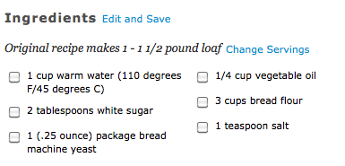

- Place the water, sugar and yeast in the pan of the bread machine (or the YPD grown cells if that’s what you’re testing).
- If you are using dried yeast, let it dissolve and foam for 10 minutes. If you are using lab grown yeast, skip this step.
- Add the oil, flour and salt to the yeast.
- Start the “basic” or “white bread” setting for the bread machine.

